**CHANGE AGENTS**

**SOCIAL JUSTICE AND THE FIRST AMENDMENT**

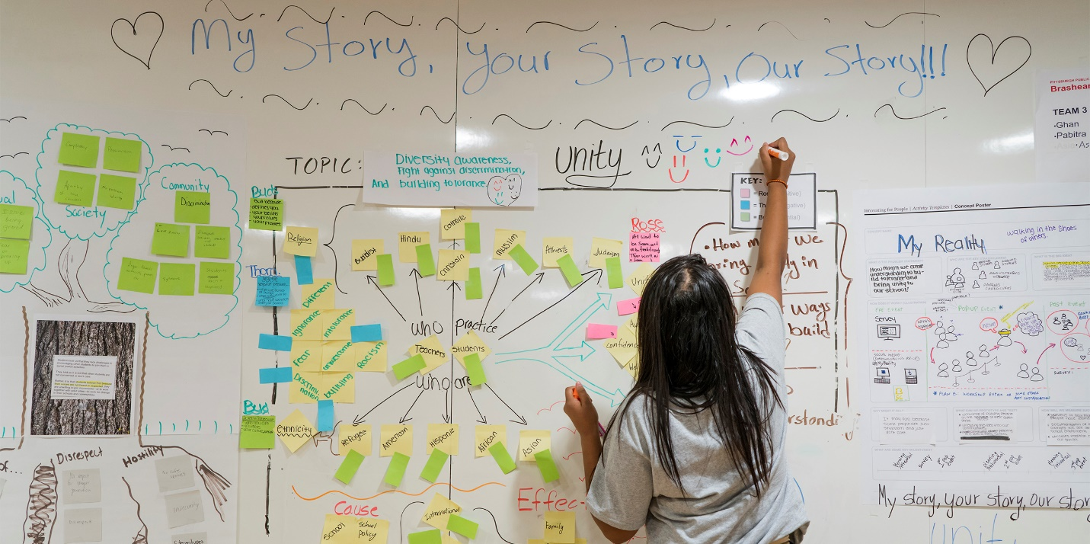

**The Pittsburgh Foundation** seeksup to 21 highly motivated youth from the Pittsburgh region to participate in a **Human-Centered Design Workshop – Change Agents in Education: Social Justice and the First Amendment.**

**WHO:** 10th, 11th and 12th graders

**WHAT:** Learn **Human-Centered Design** to create youth-designed and youth-led projects that will improve YOUR schools and YOUR communities.

**WHEN:** Must attend ALL of the following sessions in 2019:

* Thursday, Nov. 14 – 8 a.m. to 5 p.m.
* Friday, Nov. 15 – 8 a.m. to 5 p.m.
* Saturday, Nov. 16 – 8 a.m. to noon.

**WHERE:** The Pittsburgh Foundation, Five PPG Place, Suite 250, Pittsburgh, PA 15222, located in downtown Pittsburgh. Bus passes or parking will be provided.

**DETAILS:** The Foundation will provide: training offered by LUMA Institute, all supplies; breakfast and lunch; student stipends of $150 each and future financial support to carry out selected student projects developed in the seminar.

With approval from a school administrator, participation will count as an approved school absence.

**APPLICATIONS DUE: Friday, Oct. 4 by 5 p.m.**If you have any questions, please contact the Change Agents team at 412-394-2617 or 412-394-2634 or [changeagents@pghfdn.org](mailto:changeagents@pghfdn.org). Submit your application through the online form at [this link](https://pittsburghfoundation.org/change-agents) OR submit your full application via email to [changeagents@pghfdn.org](mailto:changeagents@pghfdn.org).

**What is the Change Agents in Education Program?**

**The Change Agents in Education Program** was developed to provide training in Design Thinking and Human Centered Design as a toolkit to introduce innovative ways to create change in public education and in the quality of life for youth and their families living in Pittsburgh. Since the 2012 creation of the initiative in partnership with donors Joe and Sue Ballay, six cohorts of educators and students from across Allegheny County have participated. More than 100 teachers, administrators and students have taken these new skills back to their schools, where they have worked with colleagues, students, parents and community members to begin to transform education in our region.

In November 2016, the Foundation offered its first seminar for students who want to work as Change Agents in their schools and communities. The theme was Social Justice, and the goal was to generate youth-designed and youth-led projects intended to improve their schools and their communities. Eighteen students from multiple school districts in Allegheny County participated with a goal of learning to develop problem-solving skills, think critically about issues facing their schools and communities, and conceive projects that have the potential to be transformative and create positive social change. Ultimately, student teams were eligible to receive grants to carry out rigorously designed, collaborative projects they created.

**SOCIAL JUSTICE AND THE FIRST AMENDMENT – STUDENT COHORT II**

The First Amendment states that *Congress shall make no law respecting an establishment of religion or prohibiting the free exercise thereof; or abridging the freedom of speech, or of the press; or the right of the people peaceably to assemble, and to petition the Government for a redress of grievances.*

**Adopted on Dec. 15, 1791, as one of the 10 amendments that constitute the Bill of Rights of the Constitution of the United States of America.**

#### Over the past 18 months, The Pittsburgh Foundation has been working with multiple individuals and organizations to generate dialogue and to better understand the current threats to First Amendment freedoms in the United States. A strong democracy requires that the people are informed about and understand their rights and believe that they can freely express their views without fear of governmental reprisal. An informed public requires that the people have access to, and can trust, a free press that provides reliable, timely and relevant information about critical issues that impact their lives. If the people understand their rights and believe they have the power to express their points of view in a free and unfettered manner, they will, individually and with other like-minded individuals in their community, assert those rights and address critical issues and common concerns.

#### Young people are connected to each other like never before. They are eager to contribute to efforts to protect and defend democracy locally and nationally and they are already proposing innovative solutions, driving social progress and inspiring political change.[1] Young people are agents of change, mobilizing to advance social movements to protect and defend First Amendment freedoms.

#### When young people are provided with the necessary skills and opportunities, youth-designed and youth-led initiatives can play a major role in advancing dialogue on the importance of asserting our First Amendment rights and assuring that the freedoms guaranteed in the Constitution are protected for generations to come. In this workshop, students will learn about, define and create projects with a First Amendment focus.

Change Agents in Education is designed and executed in partnership with LUMA Institute in Pittsburgh to provide youth with the tools to develop and lead efforts to create change in their school and communities. Participating students will learn Human Centered Design methods. This way of working places the needs of the people at the center of designing innovative responses to problems or social issues. Human-centered design practitioners learn to watch and actively listen, to ask people what they need rather than telling them, and to respect and value diverse opinions and points of view. Human centered design practitioners utilize the learnings gathered from observing and listening to design innovative responses to user needs.

For more examples of Human Centered Design in action, please see <https://www.youtube.com/watch?v=XNJ69PXB9Ww>

**The Goals of the Change Agents in Education Youth Cohort are to:**

* Introduce students to the principles and practice of Human-Centered Design.
* Equip youth with tools to serve as active leaders working for social justice regarding issues of the First Amendment in their own schools and communities.
* Advance students’ ability to work collaboratively in teams across multiple schools and school districts and within their home school.

**Requirements:**

Responsibilities of the student participants in Change Agents in Education include:

* Submission of an application with a team from a school and/or a community-based organization with which you are involved. Students may be in grades 10 through 12. A team must be at least two students, with at least one student in either 10th or 11th grade. A team can also be comprised of three or four students, as long as at least two students are in either 10th or 11th grade.
* Evidence of support from an adult ally in a school or community-based organization to provide guidance and assist in carrying out a student-led project after the workshop.

The ally may be a principal or other administrator, a guidance counselor, a teacher or community/nonprofit leader connected with an organization.

* A description of the issue that the team members would like to address within their school or community and why this qualifies as a First Amendment issue.
* If selected, students under 18 years of age will be asked to submit a parental permission slip at least two weeks prior to the program’s start date.
* All students are required to participate in all program sessions:

**Thursday, November 14, 2019, 8 a.m. to 5 p.m.**

**Friday, November 15, 2019, 8 a.m. to 5 p.m.**

**Saturday, November 16, 2019, 8 a.m. to noon**

The Pittsburgh Foundation will provide:

* All fees for the LUMA program. There is no direct cost to the student or the school district.
* A student stipend of $150 upon successful completion of the workshop.
* All supplies, books and materials related to the seminar.
* Port Authority bus passes for transportation from the home school to downtown Pittsburgh or parking for students who drive to downtown Pittsburgh.
* Meals and snacks on each seminar day.
* Opportunities to carry out selected student projects developed in the seminar.

**ABOUT THE PITTSBURGH FOUNDATION**

**ESTABLISHED IN 1945**, The Pittsburgh Foundation is one of the nation’s oldest community foundations and is the 14th largest of more than 750 across the United States. Our resources comprise endowment funds established by individuals, businesses and organizations with a passion for charitable giving and a deep commitment to the Pittsburgh community. The Foundation currently has more than 2,300 individual donor funds and, together with its supporting organizations, assets of more than $1.2 billion. Grantmaking benefits a broad spectrum of community life within Pittsburgh and beyond.

**APPLICATION**

Students, you must apply with an adult ally in your school and/or community group. An adult ally may be a principal, other administrator, guidance counselor, teacher or community ally connected with an organization. Serving as your ally includes advocating for your team during the creation and implementation of your project once it has been developed in the seminar.

Students must apply as a team. Students may be in grades 10 through 12. A team must be at least two students, with at least one student in either 10th or 11th grade. A team can also be comprised of three or four students, as long as at least two students are in either 10th or 11th grade.

**PART 1 –** *Each applicant must submit answers to the questions in Part 1 in a separate document. (up to four of these)*

**Name:**

**Address:**

**Cell Phone:**

**Email:**

**School and Grade:**

**Social Media Handles:**

**Parent’s/guardian’s Name:**

**Parent’s/guardian’s Phone:**

**Parent’s/guardian’s Email:**

**Neighborhood of Residence:**

**Team’s Adult Ally Information**

**Name:**

**Cell Phone:**

**Email:**

**School District/School or Organization and Position:**

**School District/Teacher Social Media Handles:**

**PART 2** *- Complete Part 2.  Team Questions*

Please answer the following questions about your team in a separate document.

* Describe a First Amendment issue that your team would like to address to improve your community and/or school. Please include information about those who are most affected by this issue, why the issue is important and what will be different if your team is successful.
* Tell us about yourselves.
* Tell us about your school.
* Describe what the term *social justice* means to your team.
* Describe what the First Amendment means to your team.

* Describe the reasons you are all interested in becoming Change Agents.
* Describe your team’s adult ally and why your team chose to ask them to work with your team on this project.
* How do you think that your school and/or community will benefit from your team’s participation in the Change Agents program?

The application must include a letter of support from your adult ally. The letter should include a brief statement regarding the school/organization’s support for the project proposed and a description of the strengths of the team and its individual members.

**APPLICATIONS DUE: Friday, Oct. 4 by 5 p.m.**If you have any questions, please contact the Change Agents team at 412-394-2617 or 412-394-2634 or [changeagents@pghfdn.org](mailto:changeagents@pghfdn.org). Submit your application through the online form at [this link](https://pittsburghfoundation.org/change-agents) OR submit your full application via email to [changeagents@pghfdn.org](mailto:changeagents@pghfdn.org).

1. Adapted from the United Nations Statement on Youth and the Sustainable Development Goals 2018. <https://www.un.org/sustainabledevelopment/youth/>. Retrieved July 10, 2019.